CSE520
Samuel Marrujo
Professor Yu
Lab 12
Draw a rotating and shrinking square using GLSL for Android

In this lab, we are to create a square that rotates and shrinks. I have successfully completed this task, and here are pictures of the following:
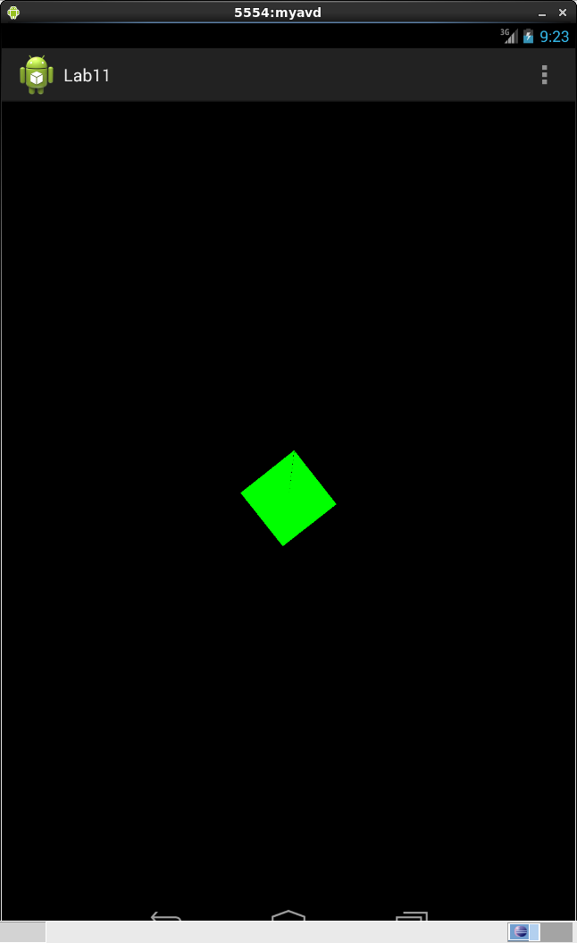
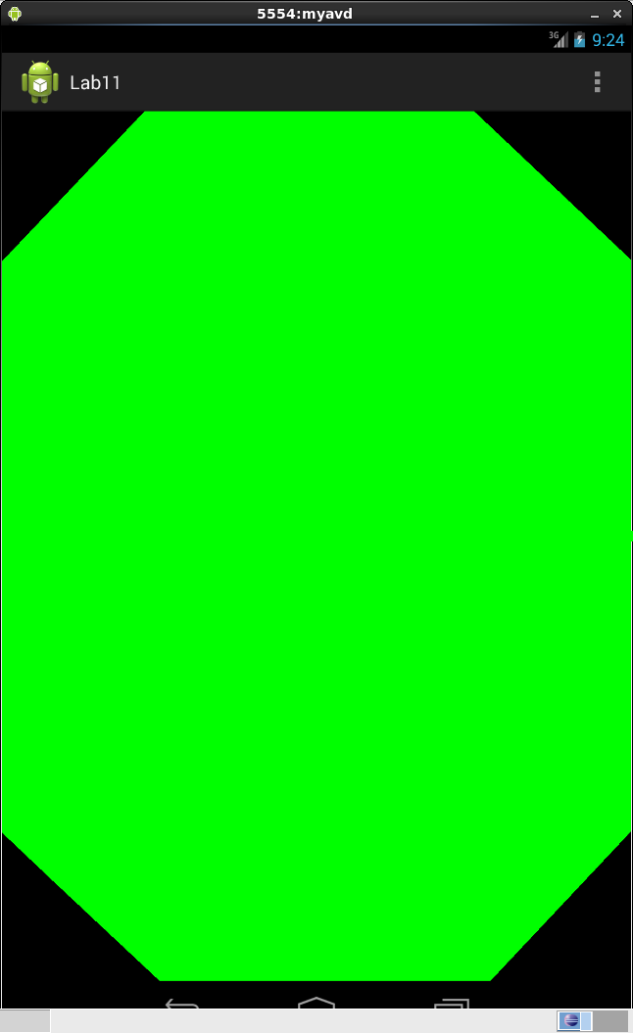
Code:

Used two same classes, with different vertices. The other class just has a different set of vertices to compile a square.

package opengles.lab11;

import java.nio.ByteBuffer;
import java.nio.ByteOrder;
import java.nio.FloatBuffer;

import android.opengl.GLES20;

public class Triangle {
// Source code of vertex shader
private final String vsCode =
"attribute vec4 vPosition;" +
"uniform mat4 uMVPMatrix;" +
"uniform float deltaT;\n" +
"void main(){ \n" +
"float s = 2.0f;" +
"s = s + 2.0 * sin ( 0.02 * deltaT );" +
"vec4 temp = vec4 ( s, s, s, 1 );" +
// The matrix must be included as part of gl_Position
// Note that the uMVPMatrix factor *must be first* in order
// for the matrix multiplication product to be correct.
" gl_Position = uMVPMatrix * (temp * vPosition ); \n" +
"} \n";

// Source code of fragment shader
private final String fsCode =
"precision mediump float;" +
"uniform vec4 vColor;" +
"void main() {" +
" gl_FragColor = vColor;" +
"}";

private int program;
private int vertexShader;
private int fragmentShader;
private FloatBuffer vertexBuffer;
private int vertexCount = 3;

// number of coordinates per vertex in this array
static final int COORDS_PER_VERTEX = 3;
static float triangleCoords[] = { // in counterclockwise order:
0.5f, 0.5f, 0.0f, // top right vertex
-0.5f, -0.5f, 0.0f, // bottom left
0.5f, -0.5f, 0.0f // bottom right
};
private float deltaT = 0.0f;
// Set color of displaying object
// with red, green, blue and alpha (opacity) values
float color[] = { 0.0f, 1.0f, 0.0f, 1.0f };

// Create a Triangle object
Triangle(){
// create empty OpenGL ES Program, load, attach, and link shaders
program = GLES20.glCreateProgram();
vertexShader = loadShader(GLES20.GL_VERTEX_SHADER, vsCode);
fragmentShader = loadShader(GLES20.GL_FRAGMENT_SHADER, fsCode);
GLES20.glAttachShader ( program, vertexShader );// add the vertex shader to program
GLES20.glAttachShader(program, fragmentShader); // add the fragment shader to program
GLES20.glLinkProgram(program); // creates OpenGL ES program executables
GLES20.glUseProgram( program); // use shader program

// initialize vertex byte buffer for shape coordinates with parameters
// (number of coordinate values * 4 bytes per float)
// use the device hardware's native byte order
ByteBuffer bb = ByteBuffer.allocateDirect( triangleCoords.length * 4);
bb.order(ByteOrder.nativeOrder());

// create a floating point buffer from the ByteBuffer
vertexBuffer = bb.asFloatBuffer();
// add the coordinates to the FloatBuffer
vertexBuffer.put(triangleCoords);
// set the buffer to read the first coordinate
vertexBuffer.position(0);
} //Triangle Constructor

public static int loadShader (int type, String shaderCode ) {

// create a vertex shader type (GLES20.GL_VERTEX_SHADER)
// or a fragment shader type (GLES20.GL_FRAGMENT_SHADER)
int shader = GLES20.glCreateShader(type);

// pass source code to the shader and compile it
GLES20.glShaderSource(shader, shaderCode);
GLES20.glCompileShader(shader);

return shader;
}
public void draw(float[] mvpMatrix) {
int mMVPMatrixHandle = GLES20.glGetUniformLocation(program, "uMVPMatrix");
GLES20.glUniformMatrix4fv(mMVPMatrixHandle, 1, false, mvpMatrix, 0);
//GLES20.glDrawArrays(GLES20.GL_TRIANGLES, 0, vertexCount);
draw();
}
public void draw() {
// Add program to OpenGL ES environment
GLES20.glUseProgram(program);

// get handle to vertex shader's attribute variable vPosition
int positionHandle = GLES20.glGetAttribLocation(program, "vPosition");
int deltaTHandle = GLES20.glGetUniformLocation(program, "deltaT");
// Enable a handle to the triangle vertices
GLES20.glEnableVertexAttribArray(positionHandle);

// Prepare the triangle coordinate data
int vertexStride = 0;
GLES20.glVertexAttribPointer(positionHandle, COORDS_PER_VERTEX,
GLES20.GL_FLOAT, false,
vertexStride, vertexBuffer);

// get handle to fragment shader's vColor member
int mColorHandle = GLES20.glGetUniformLocation(program, "vColor");

// Set color for drawing the triangle
GLES20.glUniform4fv(mColorHandle, 1, color, 0);
GLES20.glUniform1f( deltaTHandle, deltaT);
deltaT += 0.2;

// Draw the triangle
GLES20.glDrawArrays(GLES20.GL_TRIANGLES, 0, vertexCount);

// Disable vertex array
GLES20.glDisableVertexAttribArray(positionHandle);
}
}

